Thought Notes of an E-commerce Website UI:

1. Header:
   * Divide the header into two parts: the first part should include the company logo, a search box, and buttons for the cart and user login.

* The logo placed at the top-left corner which would be clickable and takes users to the home page.
* Include a search box with a magnifying glass icon, allowing users to search for products.
* The cart icon and user login button placed in the top-right corner. Clicking it should lead to their respective pages i.e cart page and login page.
  + The second part of the header will be a navigation bar containing links to products and categories Below is the list of the items which you need to link to their respective pages: Home, All Products, Women (All products, Dresses, Pants, Skirts), Men (All products, Shirts, Pants, Hoodies), Kids and Contact.

1. Footer:
   * Create a footer that mirrors the header's structure to maintain design consistency.
   * Include a list of categories and relevant links in the footer.
   * Add a copyright message at the end of the footer.

**Note:** Ensure that the header remains consistent across all pages for a unified user experience. Using JavaScript to inject header and footer into every page.

1. Home Page:
2. Cover Image:
   * Placed an attractive cover image with the company's slogan located just below the header. Ensure the image spans the entire width of the page for a visually appealing look.
   * Properly align the website's logo and slogan within the image.

2. Featured Products Section:

* + Implement a slider to showcase featured products. Ensure the slider is placed right above the footer for easy navigation.
  + Consider using 0wl's Carousel component as a reference for creating Carousel.
  + The slider must be responsive though, and in mid-sized devices 2 images showed and in small-sized devices 1 image showed and for laptop and tablet 5 images are showed.
  + Pay attention to card design, including:
    - Product images.
    - Product names and descriptions.
    - Add-to-cart button with cart logo.
  + Ensure consistency in design elements, such as fonts, colors, and spacing, to maintain a cohesive look.

1. Product Pages:
   * Create the following product pages: a. All Products Page:
     + Display all products in a grid format for easy browsing. b. Women's Category Page:
     + Include sub-categories like All Products, Dresses, Pants, and Skirts. c. Men's Category Page:
     + Provide sub-categories such as All Products, Shirts, Pants, and Hoodies. d. Kids Category Page:
     + List all kid's clothing products in an organized manner.
2. Contact Page:
   * Design a professional-looking contact us page. Use a two-column layout for the contact page.
   * In the first column, display an image that represents the business, adding a visual element that helps users identify the brand or purpose
   * Place the contact form in the second column.
   * Utilize Bootstrap and CSS to design the form elements in a visually appealing and consistent manner.
   * Include input boxes for essential information like name, email, and message.
   * Add appropriate labels and placeholders for input fields to guide users.
   * Consider using Bootstrap's form control styles for consistency and responsiveness.
   * Ensure user-friendly validation and error handling.

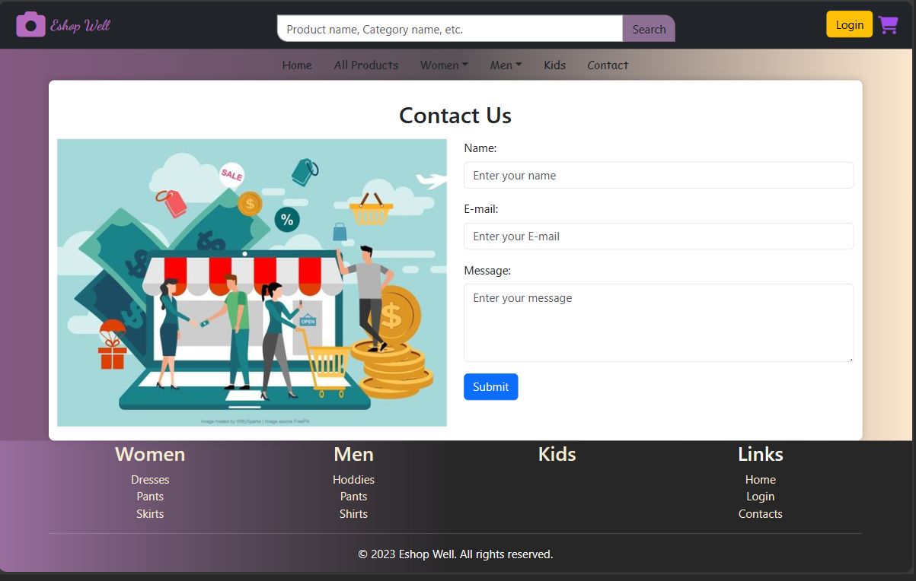 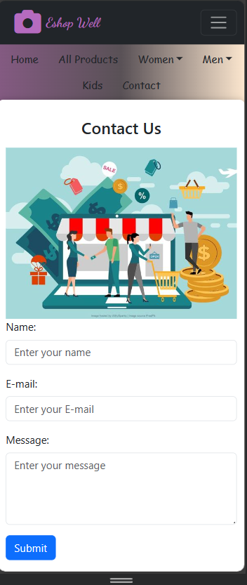

1. Login Page:
   * Create a user-friendly login page.
   * Include fields for the user's email and password.
   * Use the Bootstrap container class to ensure the login page is responsive across different screen sizes and devices.
   * Implement proper security measures for user authentication.
   * Use JavaScript to handle the login check logic after the user submits the form.
   * Check if the entered email address and password match specific values (e.g., email: "[admin@admin.com](mailto:admin@admin.com)" and password: "123456")
2. Cart Page:
   * Divide the cart page into two main parts arranged in a grid layout.
   * The first part is a section for listing the items in the cart.

* Item Listing Grid:
  + Inside the first part, create a 3-column grid for each item.
  + Column 1: Display the product's image.
  + Column 2: List the product's name and price, and include a delete button (using Font Awesome's trash icon) to remove the product from the cart.
  + Column 3: Contain a form allowing the user to increase or decrease the quantity of the product, with relevant icons for incrementing and decrementing the quantity (e.g., + and – icons).
  + For now, focus on the design, and make these features functional in the later stages of development.
* Summary Section:
  + The summary section should be presented as a bootstrap card. Card Header Label it as "Summary. "Include a row for product price (cost). Show shipping cost and its value. Separate these elements with a horizontal line for clarity. Display the total cost of the cart.
  + Include a checkout button for users to proceed to the payment process.
* Responsive Design: Ensure that the cart page layout is responsive, allowing it to adapt to different screen sizes and devices.

General Considerations:

* Ensure a responsive design to make the website accessible on various devices,
* Use consistent typography, color schemes, and branding elements throughout the website.